# SOFTWARE REQUIREMENTS SPECIFICATION

### for

**ONLINE ART GALLERY**

***Prepared by***

|  |  |  |
| --- | --- | --- |
| Martina M George | 700020 | martinamgeorge@mca.ajce.in |

|  |
| --- |
| **Project Guide: Mr Rony Tom** |
| **Date: 29-06-2018**  **DEPARTMENT OF COMPUTER APPLICATIONS, AJCE** |

# CHAPTER - 1

**INTRODUCTION**

### PURPOSE

The purpose of this document is to provide a detailed description of the ‘Online Art Gallery’. This SRS will give a complete understanding of the ‘Online Art Gallery’ to be constructed. The main purpose of ‘Online Art Gallery’ is an online application, which is used to display and sell art works of artist irrespective of their work category. Artist can register online for being a member in the art gallery and each artist can upload the digital copy of their art work under the respective categories. They can host their art work either for auction or for fixed price.

This is a database project which covers every aspect involved in a shopping. The product will avoid the burden of hard copy storage. It will also provide data security as we are using the secured databases for maintaining the documents. We can also conserve the time and human resources for doing the same task. The data can be maintained for longer period with no loss of data.

### SCOPE

The Online Art Gallery is a web based application.The system allows the online customers to search for art works available inthis site. In this site we mainly promote the artists to upload their art works and personal details. Exhibition of art works also can be conduct.

Art lovers have to go to the art exhibition to collect their favorite arts or painting. But now a days they are not getting enough time to go to the galleries and collect the arts and paintings.

Major functional modules:

* + - Registration and login
    - Artist authorization
    - Art exhibition
    - Bill generation
    - Viewing and select items
    - Search items
    - Order and rating the items
    - Feedback Entry
  1. **DEFINITIONS, ACRONYMS, AND ABBREVIATIONS**
  2. **REFERENCES**

## OVERVIEW

#### EXISTING SYSTEM

customer can also register online and they can browse art works that are arranged in different categories. Each customer can create their own gallery to see his favorite art works without much difficult. And each user has the right to purchase an art work using the integrated payment gateway.

#### DRAWBACKS OF EXISTING SYSTEM

* + 1. Limited number of facilities available to search particular art
    2. Time consuming
    3. Limitation of auction

#### PROPOSED SYSTEM

The proposed system allows registration and login. It allows to manage the art items sales and purchases.It also conduct effective exhibition of the art works. It maintains the stock information. The users can perform online shopping.

The main features include:

* + 1. Registration and login
    2. Artist authorization
    3. Art exhibition
    4. Bill generation
    5. Viewing and select items
    6. Search items
    7. Order and rating the items
    8. Feedback Entry

#### ADVANTAGES OF PROPOSED SYSTEM

The system is very simple in design and to implement. The system requires very low system resources and it will work in almost all configurations. It has got following features:

The main advantages :-

* Keep the history of famous artists and their famous works.
* Provide different category of art works.
* Promote the known and unknown artists among worldwide.
* Conduct exhibition for artists.
* Perform rating to the particular artist based on their works.

# CHAPTER - 2

**OVERALL DESCRIPTION**

## PRODUCT PERSPECTIVE:

The Online art gallery system is an independent product that facilitate online shopping of the art items of the artists. It maintains all the details related to the various customers and artists involved in the Online art gallery system. The Online art gallery system keeps all the details of the available products including category, specialization. It handles the payments made by the different customers of the Online art gallery. Online art gallery also leads efficient exhibition. There is online shopping facility and after rating facility can also give to the customer to rate the quality of the purchased item by the customer.

## PRODUCT FUNCTIONS/FEATURES:

The objective is to build a software system that is user friendly and accurately arrange the items according to the artist, category etc. The software system should be convenient for its users. The aim of proposed system is to develop a system with improved facilities.

The major functional modules are:

* **User Registration and Login**

Register each userthat are **-** artists and customers to access the site.

* + 1. **Artist Management**
* **Artist authorization**

Authorization or verification of artists done by admin on the basis of information provided during registration time. Only after the admin approval, each artist become

authorized user.

* **Exhibition coordinating and art competition**

The admin host art exhibitions and art competition. Art exhibitions are very helpful to present one of the talent artist to the world, in the exhibitions each artist can present their own works. Art competitions is used to find out the most talented artist by conducting different competition for different categories of art work.

* **Bill generation**

After the successful purchase of one or more items corresponding bill get generate.

* + 1. **Artist Management**
* **Viewing and select items**

The customer can see all items in the site. From the already displayed items, customers can select items.

* **Search items**

This site provides mechanism to search the interested art works based on category wise, Artist wise.

* **Order and rating the items**

The customer can order the products from the art gallery of the site and can rate the items by customers.

* **Feedback Entry**

The customer can enter feedback about purchased items. On the basis future recommendation held.

## USER CHARACTERISTICS:

The Online Art Gallery System has 3 users.

1. **Admin**

The admin keeps user’s registration information and verify each artist on the basis of their entered details. The admin host art exhibitions and art competitions. The admin provide details about offers and manage bill generation and payment respectively.

1. **Artist**

This site also provides individual account for each artists after their successful registration. They are logging into the site and upload art works and description.

1. **Customer**

The customer can view the art gallery. It provides mechanism to search the interested art works based on category wise, Artist wise. The customer can order the products and can rate their favorite artist on the basis of artist’s works. The customer can enter feedback about purchased items.

## OPERATING ENVIRONMENT

#### Hardware Specification

Processor : Pentium IV/AMD Dual core or above

RAM : 2 GB and above

Hard disk : 500 GB and above

#### Software Specification

#### CONSTRAINTS:

It provides the genera1 description of the constraints such as regulatory policies, audit functions, reliability requirements, and so on.

#### USER DOCUMENTATION

The ‘Online Art Gallery System’ will provide a user’s manual for the administrator. To assist the user in understanding the product better and to assist them in better utilization of the product and its features, we will be providing an interactive user interface (in DOC format).

#### ASSUMPTION AND DEPENDENCY

We are assuming that the users will not use our product to download copyright. Also, we expect that the users not only use the software to view resources, they will also be updating details and resources for being viewed by other users. We also assume that product users will not do malicious activities on the software.

# CHAPTER - 3

**SPECIFIC REQUIREMENTS**

### EXTERNAL INTERFACE REQUIREMENTS

The “**Online Art Gallery System**” will use the following input/output devices for a personal computer. The external interfaces are:

* + - Keyboard
    - Mouse
    - Monitor
    - Printer
    - Mobile phone

#### User Interfaces

|  |  |
| --- | --- |
| **FORMS** | **DESCRIPTION** |
| Home | Log into the site as a Administrator,  Artist, or Ordinary User. |
| User Registration | Administrator, Artist and Ordinary User can register to get  access. |
| Artist Management | Save artist information, view  and update them |
| Online Shopping | The users can perform online  shopping and payments. |
| Customer Management | Save customer information, view  and update them |
| Exhibition Hosting | Exhibition of art works of the particular artist should be conduct. |
| Sales and Purchase | Prepare Bills for sales and add  purchase details. |
| Stock Management | View and update stock as sales and purchases are done. |
| Feedback/Comments and Rating | The users can post comments/feedbacks and can rates item. |

* + 1. **Hardware Interfaces**

**Online Art Gallery System** is a web based application.

#### Software Interfaces

#### Communications Interfaces

* 1. **FUNCTIONAL REQUIREMENTS**

Functional requirements define the fundamental actions of the system must perform. The functional requirements for the system are divided into some main categories Artist management,online shopping, Customer Management, Exhibition Hosting,Stock Management, Sales and purchases.

#### Registration

* + - 1. Introduction

The users can register in to the system. There is an artist registration and ordinary user registration. Artists are registered by the admin or manager. The ordinary users can directly register their details.

* + - 1. Inputs

. In this module, for artist registration, the artist information like artist number, name, address, contact details, email_id, their specialized art/item works details etc are entered into the database. The artist can be registered using email-id or phone number. For ordinary user registration, email id, phone number, name and password are given.

* + - 1. Processing

After artist registration, the username and password are send to them by mail. Then the artist can login to the site and can update personal information and password.

* + - 1. Outputs

When registration is completed, a success message is displayed in case of artist. The ordinary users are directed to their home page.

* + - 1. Error Handling

During the registration process, all the inputs are validated and if there is any error, it is displayed. If a username is already in use, it also displayed.

#### Artist Management

* + - 1. Introduction

This module is used to manage artist activities related with their item uploading and other details of the items entering.

* + - 1. Inputs

The artist enters their own art works and related images of the items.

* + - 1. Processing

According to the items selected by the customers, performs shipping of the items to the particular address of the customer.

* + - 1. Outputs

Report for each activity (like shipping) of the artist get generated.

* + - 1. Error Handling

If an shipping item detail is entered incorrectly, it can be changed.

#### Customer Management

3.2.3.1 Introduction

This module is for handling the customer.

3.2.3.1 Inputs

Customer’s personal details, selected item details, shipping address etc.

3.2.3.2Processing

Add interested items into the cart.

Then, specify shipping address.

3.2.3.3Outputs

Total amount for the items should be credited to each artist of the item.

3.3.3.4Error Handling

Banking transations and shipping of the items get trouble.

#### 3.2.4 Sales and Purchases

3.2.4.1Introduction

The sales and purchase details are stored in the database.

3.2.4.2Inputs

The sales and purchase details such as product name, quantity, unit price, category, brand, supplier information etc. are entered into the database

3.2.4.3Processing

3.2.4.4Outputs

The daily and monthly reports can be taken from this data.

3.2.4.5Error Handling

#### 3.2.5 Stock Management

3.2.5.1 Introduction

As the sales and purchases are done, the stock quantity is updated. the stock status can be viewed by the admin/artist.

3.2.5.2.Inputs

item details, quantity

* + - 1. Processing
      2. Outputs

stock status and quantity

* + - 1. Error Handling

Available quantity is displayed to users so that errors can be avoided.

#### 3.2.6 Online Shopping

3.2.6.1 Introduction

This module allows to perform online shopping. The products are displayed and the users can add them to shopping cart. They can make payment by entering card number, cvv, card expiry date and name on card.

* + - 1. Inputs

item details,quantity,card details

* + - 1. Processing
      2. Outputs shopping can be done
      3. Error Handling

shipping address is checked when user enters them.

#### INPUT FORMS

1. Home Page of Online Art Gallery

Online Art Gallery Home Page

Panchayat *



About Us

Contact Us

Gallery

Register

Login

1. Login Form



Username

Password

Login

Cancel

1. Customer Registration Form



Register

Password *

User Name/Email *

Male Female Others

Gender *

Phone

Name

Customer Registration Form

Address *

1. **Artist Registration Form**



Phone

Name

Artist Registration Form

Photo*

Browser

Gender *

Male Female Others

Address *

User Name/Email *

Password *

Register

1. **Add Item Form**



Item

Add Item Form

Item Photo

Browser

Artist

Item Category

Item Type

Total Stock

Available Stock

Price

Add

1. **Add Cart Form**

Order Form

Panchayat *



Item

Add Cart

Artist

Type

Order

Price

Quantity Quantity

Bank

Description Description Quantity

Order Date Description Quantity

Add

1. **Bank Details Form**

Bank Form

Panchayat *



Credit Card No:

Add Cart

Card Name

Card Type

Order

CVV No:

Amount Paid Description Quantity

Bank

Expiry Date Description Quantity

Add

1. **Exhibition Details Form**

Exhibition Form



Panchayat *

Item

Artist

Item Description Quantity

Exhibit Date Quantity

Add

* + 1. **Output Form**

1. **Payment Form**

Payment Form



Panchayat *

Card No:

Amount Paid

OK

**3.7 Other Documents**

**3.7.1 DATA FLOW DIAGRAM**

1. Context Level of Online Art Gallery

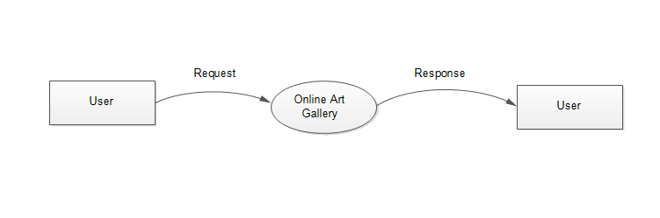

1. First Level DFD of Admin for Online Art Gallery

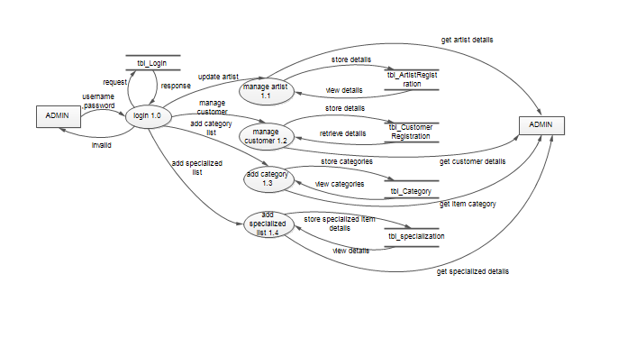

1. First Level DFD of Artist for Online Art Gallery

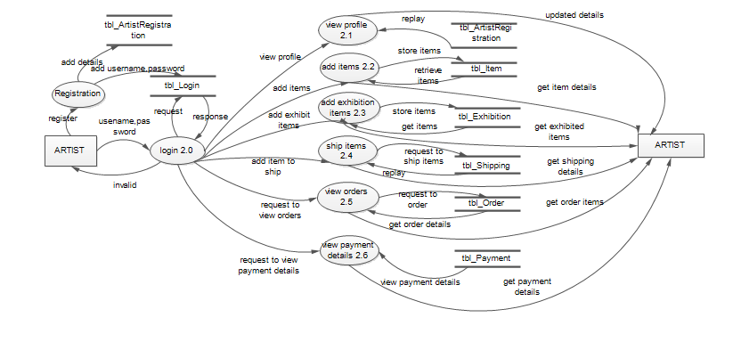

1. First Level DFD of Customer for Online Art Gallery

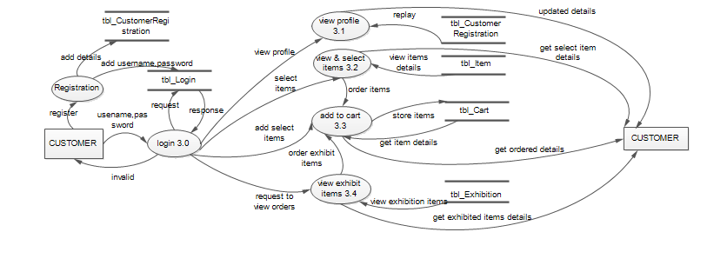

1. Second Level DFD of Customer For Add Cart

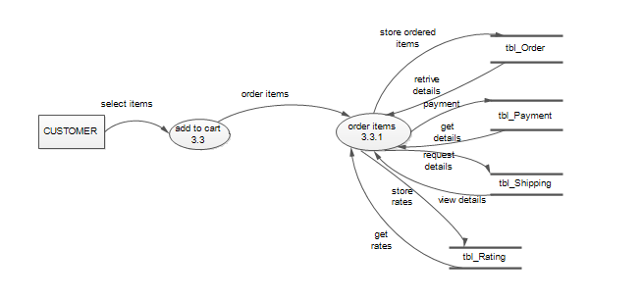

### USE CASE DIAGRAM

* + 1. **SEQUENCE DIAGRAM**

**3.7.4 TABLE DESIGN**

Table Design of Online Art Gallery

1. tbl_Login

|  |  |  |  |  |
| --- | --- | --- | --- | --- |
| FIELD NAME | FIELD TYPE | SIZE | CONSTRIANT | DESCRIPTION |
| login_id | int | 5 | Primary key | login id |
| Username | varchar | 25 |  | username |
| Password | varchar | 25 |  | password |
| Type | int | 5 |  | role/type |
| Status | int | 5 |  | status |

Primary key: login_id

2. tbl_CustomerRegistration

|  |  |  |  |  |
| --- | --- | --- | --- | --- |
| FIELD NAME | FIELD TYPE | SIZE | CONSTRIANTS | DESCRIPTION |
| cust_id | int | 5 | Primary key | Customer id |
| loginid | int | 5 | Foreign key | Login id of customer |
| cust_name | varchar | 20 |  | Customer name |
| cust_mobile | varchar | 20 |  | Mobile number for contact |
| cust_email | varchar | 15 |  | Email id |
| cust_address | varchar | 100 |  | Customer address |
| cust_status | int | 5 |  | Customer status |

Primary key: cust_id

Foreign key: login_id (tbl_Login)

3.tbl_Specialization

|  |  |  |  |  |
| --- | --- | --- | --- | --- |
| FIELD NAME | FIELD TYPE | SIZE | CONSTRIANTS | DESCRIPTION |
| spec_id | Int | 5 | Primary key | Specialization id |
| spec_name | varchar | 20 |  | Specialization name |
| spec_status | Int | 5 |  | Specialization status |

Primary key: spec_id

4. tbl_ItemCategory

|  |  |  |  |  |
| --- | --- | --- | --- | --- |
| FIELD NAME | FIELD TYPE | SIZE | CONSTRIANTS | DESCRIPTION |
| cat_id | Int | 5 | Primary key | Category id |
| spec_id | Int | 5 | Foreign key | Specialization id |
| cat_name | varchar | 20 |  | Category name |
| cat_status | Int | 5 |  | Category status |

Primary key: cat_id

Foreign key: spec_id (tbl_Specialization)

5. tbl_ArtistRegistration

|  |  |  |  |  |
| --- | --- | --- | --- | --- |
| FIELD NAME | FIELD TYPE | SIZE | CONSTRIANTS | DESCRIPTION |
| art_id | Int | 5 | Primary key | Artist id |
| login_id | Int | 5 | Foreign key | Login id of artist |
| art_name | Varchar | 20 |  | Artist name |
| art_mobile | Varchar | 20 |  | Artist mobile number |
| art_email | Varchar | 20 |  | Artist email id |
| art_photopath | Varchar | 150 |  | Artist photo path |
| art_address | Varchar | 100 |  | Artist address |
| art_status | Int | 5 |  | Artist status |

Primary key: art_id

Foreign key: login_id (tbl_Login)

6. tbl_Cart

|  |  |  |  |  |
| --- | --- | --- | --- | --- |
| FIELD NAME | FIELD TYPE | SIZE | CONSTRIANTS | DESCRIPTION |
| cart_id | int | 5 | Primary key | Cart id |
| cust_id | int | 5 | Foreign key | Customer id |
| item_id | int | 5 | Foreign key | Item id |
| itemph_id | int | 5 | Foreign key | Item photo id |
| cart_qty | int | 20 |  | Number of items |
| cart_comment | varchar | 100 |  | Comment about the availability of the item |
| cart_totalprice | float | 30 |  | Total price |
| cart_status | int | 5 |  | Cart status |

Primary key: cart_id

Foreign key: cust_id (tbl_Customer),item_id (tbl_Item),itemph_id (tbl_ItemPhoto)

7. tbl_Item

|  |  |  |  |  |
| --- | --- | --- | --- | --- |
| FIELD NAME | FIELD TYPE | SIZE | CONSTRIANTS | DESCRIPTION |
| item_id | int | 5 | Primary key | Item id |
| art_id | int | 5 | Foreign key | Artist id |
| cat_id | int | 5 | Foreign key | Category id |
| spec_id | int | 5 | Foreign key | Specialization id |
| item_name | varchar | 20 |  | Item name |
| itemph_id | varchar | 100 |  | Item photo path |
| item_des | varchar | 100 |  | Item description |
| i_totalstock | int | 50 |  | Total item stock |
| i_avstock | int | 50 |  | Available item stock |
| item_price | float | 50 |  | Item price |
| item_status | int | 5 |  | Item status |

Primary key: item_id

Foreign keys: art_id (tbl_Artist),cat_id (tbl_Category),spec_id (tbl_Specialization)

8.tbl_Order

|  |  |  |  |  |
| --- | --- | --- | --- | --- |
| FIELD NAME | FIELD TYPE | SIZE | CONSTRIANTS | DESCRIPTION |
| order_id | int | 5 | Primary key | Order id |
| cust_id | int | 5 | Foreign key | Customer id |
| item_id | int | 5 | Foreign key | Item id |
| itemph_id | int | 5 | Foreign key | Item photo id |
| order_date | date | 10 |  | Order date |
| order_qty | int | 30 |  | Order quantity |
| order_price | float | 50 |  | Total price |
| order_status | int | 5 |  | Status of order |
| pay_status | int | 5 |  | Status of payment |

Primary key: order_id

Foreign key: cust_id (tbl_Customer),item_id (tbl_Item),itemph_id (tbl_ItemPhoto)

9. tbl_Bank

|  |  |  |  |  |
| --- | --- | --- | --- | --- |
| FIELD NAME | FIELD TYPE | SIZE | CONSTRIANTS | DESCRIPTION |
| bank_cno | int | 10 | Primary key | Bank card number |
| cust_id | int | 5 | Foreign key | Customer id |
| bank_cname | varchar | 20 |  | Card name |
| bank_ctype | varchar | 20 |  | Card type |
| bank_cvvno | varchar | 20 |  | Cvv number |
| bank_expriydate | date | 10 |  | Expriy date of card |
| bank_bal | float | 10 |  | Bank blance |
| bank_status | int | 5 |  | Bank status |

Primary key: bank_cno

Foreign key: cust_id (tbl_Customer)

10. tbl_Payment

|  |  |  |  |  |
| --- | --- | --- | --- | --- |
| FIELD NAME | FIELD TYPE | SIZE | CONSTRIANTS | DESCRIPTION |
| pay_id | int | 5 | Primary key | Payment id |
| cust_id | int | 5 | Foreign key | Customer id |
| bank_cno | int | 10 | Foreign key | Card number |
| pay_total | float | 25 |  | Total amount pay |
| pay_status | int | 5 |  | Payment status |

Primary key: pay_id

Foreign key: cust_id (tbl_Customer),bank_cno(tbl_Bank)

11. tbl_Shipping

|  |  |  |  |  |
| --- | --- | --- | --- | --- |
| FIELD NAME | FIELD TYPE | SIZE | CONSTRIANTS | DESCRIPTION |
| ship_id | int | 5 | Primary key | Shipping id |
| order_id | int | 5 | Foreign key | Order id |
| item_id | int | 5 | Foreign key | Item id |
| pay_id | int | 5 | Foreign key | Payment id |
| ship_mobile | int | 20 |  | Mobile number |
| ship_address | varchar | 100 |  | Shipping address |
| ship_status | int | 5 |  | Shipping status |

Primary key: ship_id

Foreign key: order_id (tbl_Order),item_id (tbl_Item),pay_id (tbl_Payment)

12. tbl_Exhibition

|  |  |  |  |  |
| --- | --- | --- | --- | --- |
| FIELD NAME | FIELD TYPE | SIZE | CONSTRIANTS | DESCRIPTION |
| ex_id | int | 5 | Primary key | Exhibition id |
| item_id | int | 5 | Foreign key | Item id |
| art_id | int | 5 | Foreign key | Artist id |
| ex_itemdes | varchar | 50 |  | Exhibition item description |
| ex_date | date | 20 |  | Exhibition date |
| ex_status | int | 5 |  | Exhibition status |

Primary key: ex_id

Foreign keys: item_id (tbl_Item),art_id (tbl_Artist)

13. tbl_Rating

|  |  |  |  |  |
| --- | --- | --- | --- | --- |
| FIELD NAME | FIELD TYPE | SIZE | CONSTRIANTS | DESCRIPTION |
| rat_id | int | 5 | Primary key | Rating id |
| cust_id | int | 5 | Foreign key | Customer id |
| item_id | int | 5 | Foreign key | Item it |
| Ratings | int | 10 |  | Ratings of item |
| rat_comment | varchar | 50 |  | Comment on item |
| rat_status | int | 5 |  | Rating status |

Primary key: rat_id

Foreign keys: item_id (tbl_Item),cust_id (tbl_Customer)

14. tbl_ItemPhoto

|  |  |  |  |  |
| --- | --- | --- | --- | --- |
| FIELD NAME | FIELD TYPE | SIZE | CONSTRIANTS | DESCRIPTION |
| itemph_id | int | 5 | Primary key | Item photo id |
| item_id | int | 5 | Foreign key | Item id |
| itemph_path | varchar | 50 |  | Path of the photo |

Primary key: itemph_id

Foreign key: item_id (tbl_Item)